# Guideline 5 TCP/IP Server Data Streaming

Cosmin Serban, 07/09/2021

## Configuring the TCP/IP Server

The Guideline 5 features a TCP/IP Server that can accept connections from third party clients running on a different machine on a specified port. To enable the server functionality, go to Control Panel, Data Settings and make sure that the *Enable* box is checked. The default TCP port is 2567, but can be changed in this tab.

By default, the TCP/IP server transfers information regarding the current depth for each drive, root mean square (RMS) for each mapped MER channel and the mean firing rate (MFR) for each channel, along with information regarding stimulation parameters when stimulation is in progress.

The TCP/IP server can stream MER, LFP and Auxiliary data, but these have to be enabled on a as needed basis, to avoid occupying bandwidth and requiring the clients to handle unnecessary information. Check the corresponding box to enable either data modality streaming. The data modalities can be streamed concurrently.

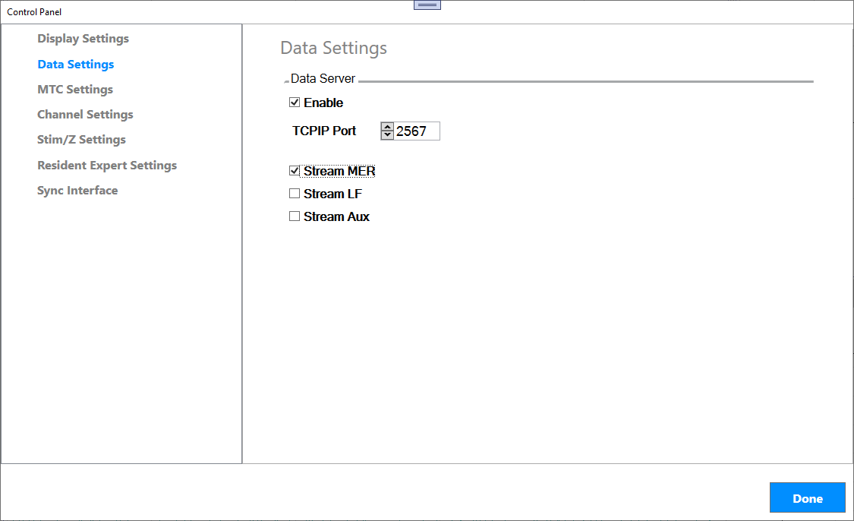

## Example Matlab TCP/IP client

The Matlab scripts referenced below can be downloaded from the Github public repository: <https://github.com/fhcinc/Matlab/tree/master/Guideline5>

The example Matlab script referred to below is *mer_online.m* and can be used as a starting point to handle MER and LFP data on a custom client software.

**Pre-requisites:**

The mer_online.m script requires the following to be in the same folder as the main script:

* *pnet* library (either x64 or x86 version, depending on the Matlab installation)
* *message_codes.m*: this is a script containing all message codes particular to the Guideline 5 data stream. This file also documents the contents of each message type.
* *legacy_codes*.*m*: A script containing message codes belonging to the Guideline 4000 LP+ software, some of which are still available with the Guideline 5.

**Running the script:**

When using an Ethernet connection to the Guideline 5 laptop, use the IP address ‘192.168.0.2’.

>> mer_online (‘192.168.0.2’)

The script features two flags that enable showing figures for MER or LFP.



**Notes:**

* Upon successful connection, the TCP Server sends information about the data first: MER and LFP sample rate and their calibration constants. The calibration constants are used to transform the MER and LFP samples to microvolts.
* The information about drive depth, mean firing rate and root mean square use the same format as the Guideline 4000 LP+ software.
* The MER and LFP data is packaged differently than the Guideline 4000 (please refer to the next section for more details on the general message structure).
* The MER is received under the ADS_DATA_MER code



* The LFP is received under the LFP_DATA_RAW code



## Guideline 5 GLD format

The Guideline 5 stores data records in a file format named GLD.

Information between the Guideline 5 system and the Guideline 5 software, as well as between the Guideline 5 TCP server and the custom TCP client is exchanged using a custom protocol named eRPC. The message types defined by the protocol are described in the accompanying document, Guideline 5 Embedded Remote Procedure Call.docx.

FHC, Inc. provides the GLDFile.m Matlab script and Python counterpart to allow parsing of GLD files stored by the Guideline 5 system.